mysql -u root -p
Enter password: root
create database MCA;
use MCA;
CREATE TABLE student ( RollNo INT PRIMARY KEY, Name VARCHAR(255), Course VARCHAR(50), Year INT );

desc student;

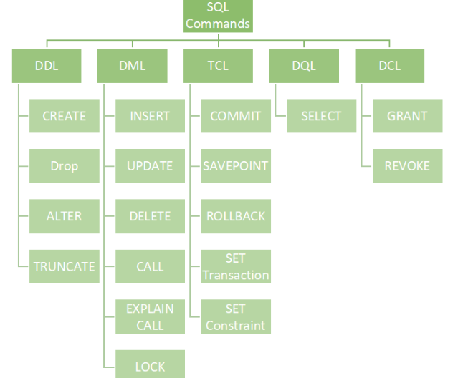

Data Definition Language (DDL)
DDL is used for specifying the database schema. It is used for creating tables, schema, indexes, constraints etc. in database. Let’s see the operations that we can perform on database using DDL:
- To create the database instance – CREATE
CREATE DATABASE databaseName;

You can verify the successful creation of database using show databases statement.
SHOW DATABASES;
- To alter the structure of database – ALTER
The ALTER TABLE statement is used to add, delete, or modify columns in an existing table.
To add a column in a table, use the following syntax:
ALTER TABLE table_name ADD column_name datatype;
To delete a column in a table, use the following syntax (notice that some database systems don't allow deleting a column):
ALTER TABLE table_name DROP COLUMN column_name;
To rename a column in a table, use the following syntax:
ALTER TABLE table_name RENAME COLUMN old_name to new_name;
OR
Alter Table table_name change old_name new_name data_type;
- To drop database instances – DROP
The DROP DATABASE statement is used to drop an existing SQL database.
DROP DATABASE databasename;
The DROP TABLE statement is used to drop an existing table in a database.
DROP TABLE table_name;
- To delete tables in a database instance – TRUNCATE
The TRUNCATE TABLE statement is used to delete the data inside a table, but not the table itself.
TRUNCATE TABLE table_name;
- To rename database instances – RENAME
The SQL RANME DATABASE...TO statement is used to rename an existing user-created database.
RENAME DATABASE OldDatabaseName TO NewDatabaseName;
- To Comment – Comment
Single line comments start with –
--Select all:
SELECT * FROM Customers;
All of these commands either defines or update the database schema that’s why they come under Data Definition language.

Data Manipulation Language (DML)
DML is used for accessing and manipulating data in a database. The following operations on database comes under DML:
- To read records from table(s) – SELECT
SELECT column1, column2, ...FROM table_name WHERE condition;
- To insert record(s) into the table(s) – INSERT
INSERT INTO table_name (column1, column2, column3, ...) VALUES (value1, value2, value3, ...);
- Update the data in table(s) – UPDATE
UPDATE table_name SET column1 = value1, column2 = value2, ...WHERE condition;
- Delete all the records from the table – DELETE
DELETE FROM table_name WHERE condition;

Data Control language (DCL) → (grant,revoke)
DCL is used for granting and revoking user access on a database –
- To grant access to user – GRANT
First, we need to create a new user. The syntax is:
CREATE USER name IDENTIFIED BY 'password';
Eg: create user ‘abin’ identified by ‘ncs007’;

Next, execute the SHOW GRANT statement to check the privileges assigned to “abin” using the following query:

SHOW GRANTS FOR abin;
GRANT privilege_name(s) ON object TO user_name;
Eg: grant all on employee to abin;
- To revoke access from user – REVOKE
REVOKE privilege_name ON object_name FROM user_name;
Eg:revoke all on employee from abin;

Transaction Control Language (TCL)→ (commit,rollback,savepoint).
The changes in the database that we made using DML commands are either performed or rollbacked using TCL.
- COMMIT
The COMMIT command is used to save changes made during a transaction to the database permanently:
Eg: -- SQL statements
COMMIT;
- ROLLBACK
The ROLLBACK command is used to undo changes made during a transaction:
Eg: -- SQL statements
ROLLBACK;
- SAVEPOINT
The SAVEPOINT command allows you to set a point within a transaction to which you can later roll back:
Eg: -- SQL statements
SAVEPOINT my_savepoint;
-- More SQL statements
ROLLBACK TO my_savepoint;

Practical Questions
1. Execute DDL statements
  - Create a table Student with fields (RollNo,Name,Age,Course,Year).
  - Alter table.
  - Drop table.
  - Truncate table.
Write necessary query statements.
Ans:
Create Table:
CREATE TABLE Student ( RollNo INT PRIMARY KEY, Name VARCHAR(255), Age INT,Course VARCHAR(50), Year INT );
This creates a table named "Student" with columns RollNo, Name, Course, and Year.
Alter Table: For example, let's say you want to add a new column "Marks" to the existing table:
ALTER TABLE Student ADD Marks INT;
This adds a new column "Marks" of type INT to the "Student" table.
Drop Table: To delete (drop) the entire table:
DROP TABLE Student;
This removes the entire "Student" table and all its data.
Truncate Table: To remove all rows from the table but keep the table structure:
TRUNCATE TABLE Student;
This deletes all rows from the "Student" table, leaving an empty table with the same structure.
2. Execute DML statements(Select,Insert,Update,Delete)
- Create table Employee (Emp_Id,Emp_Name,Dept_Id,Salary) And Also create another table Department (Dept_Id,Dept_Name,Dept_Head)
- Insert minimum of 4 rows.
- Set Primary Key and Foreign Key constraints.
- Display the records.
- Update a record.
- Delete a record.

Ans:
- SQL> create table employee(Emp_id int,Emp_name varchar(20),Dept_Id int,Salary int);
SQL> insert into employee values(101,'Ben',1,1000);
SQL> insert into employee values(102,'Biby',2,1500);
SQL> insert into employee values(103,'Benoi',3,2500);
SQL> insert into employee values(104,'Joel',4,3500);
- SQL> create table department(Dept_id int,Dept_name varchar(20),Dept_Head varchar(20));
SQL> insert into department values (1,'Accounting','Alan');
SQL> insert into department values (2,'Production','Arun');
SQL> insert into department values (3,'HR','Nandu');
SQL> insert into department values (4,'Research','Atul');
- SQL> alter table employee add primary key(Emp_id);
SQL> alter table department add primary key(Dept_id);
SQL> alter table employee add foreign key(Dept_Id) references department(Dept_id);
- SQL> select * from employee;
SQL> select * from department;
- SQL> update department set Dept_Head='Fasil' where Dept_id=4;
- SQL> delete from employee where Emp_id=105;
3. Create a table and execute DCL statements (grant,revoke).
Ans:
SQL> CREATE TABLE EMPLOYEE (
Emp_Id INTEGER PRIMARY KEY,
Emp_Name TEXT NOT NULL,
Emp_Add TEXT NOT NULL,
Emp_Phone TEXT NOT NULL,
Dept_Id TEXT NOT NULL,
Dept_Name TEXT NOT NULL,
Salary TEXT NOT NULL);
INSERT INTO EMPLOYEE VALUES (1, 'Ramesh', 'GNoida','9855498465', '3445', 'Sales','25000');
INSERT INTO EMPLOYEE VALUES (2, 'Suresh', 'GNoida','98565498465', '0072', 'Sales','75000');
INSERT INTO EMPLOYEE VALUES (3, 'Rajesh', 'GNoida','9855497865', '2324', 'Sales','28000');
INSERT INTO EMPLOYEE VALUES (4, 'Shyamu', 'BSB','9853698465', '8883', 'Sales','35000');
INSERT INTO EMPLOYEE VALUES (5, 'Ramu', 'BSB','9855498235', '74568', 'Sales','96000');
SQL> select * from EMPLOYEE;
SQL> create user ‘xyz’ identified by ‘a11’;
SQL>show grants for xyz;
SQL> grant all on employee to xyz;
SQL> select * from EMPLOYEE;
SQL>revoke all on employee from xyz;
SQL> select * from EMPLOYEE;

4. Create a table and execute TCL statements (commit,rollback,savepoint).
Ans:
SQL> create table student(rollno int,name varchar(20),course varchar(20));
SQL> insert into student values(1,'Ammu','MCA');
SQL> insert into student values(2,'Amal','MCA');
SQL> savepoint a;
SQL> select * from student;
SQL> insert into student values(3,'Anju','MCA');
SQL> insert into student values(4,'Anet','MCA');
SQL> select * from student;
SQL> rollback to a;
SQL> select * from student;
SQL> commit;
SQL> insert into student values(5,'Arun','MCA');
SQL> select * from student;
SQL> rollback;
SQL> select * from student;

5. Accessing database (SELECT, Filtering using WHERE, HAVING, GROUP BY, ORDER BY Clauses, Subquery and View)

The HAVING clause in SQL is similar to the WHERE clause that is used to filter the data but in a different way.
HAVING clause is used to filter the result obtained by the GROUP BY clause
It is used with the aggregation function
It can include one or more conditions
The order of execution of the HAVING clause is after the GROUP BY clause and before the ORDER BY clause.
It can only be used with the SQL SELECT clause
Syntax
SELECT column_names
FROM table_name
WHERE conditions
GROUP BY column_name
HAVING conditions
ORDER BY column_name;
- Consider the database (Employee) that contains the record Employee ID, Name, Department, Education, and their salary in Lacs.
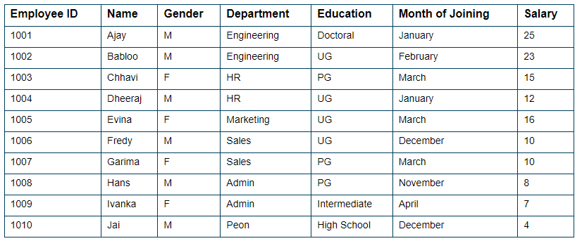
1) (i): Calculate the sum of salaries of each department.
(ii): Find the departments in which the SUM of the salaries is greater than or equal to 20 lacs
(iii) Display distinct department of Employee.
(iv) Display total number of Salary of Employees.
(v) Display details of Employees from Employee tables in which Department of the employee is Engineering and Education is Doctorial.
(vi) Display details of Employees from Employee tables in which Department of the employee is Engineering or Education is Doctorial.
(vii) Rename the columns "Name" and "Education" to "First_Name" and "Qualification", respectively.
(viii)List records of Employees whose names start with “A”.
2) Find the department in which SUM salary is greater than or equal to 20 lacs, but the education of employees is not UG.
3) Find the departments in which the SUM of the salaries is greater than or equal to 15 lacs and arrange the Salary in descending order.

- SELECT Department, SUM(Salary)
FROM Employee from employeee
GROUP BY Department;
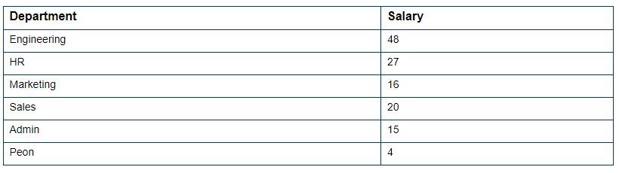
- SELECT Department, SUM(Salary)
FROM Employee
GROUP BY Department
HAVING SUM(Salary) >= 20;

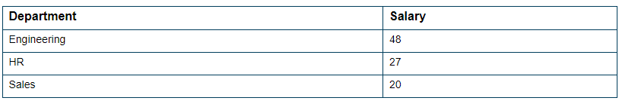
- SELECT DISTINCT Department FROM Employee;

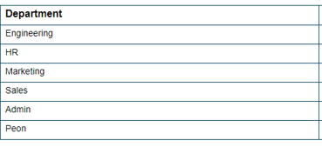
- SELECT COUNT(Salary) FROM Employee;

10
- SELECT * FROM Employee where Department='Engineering' and Education='Doctorial';

- SELECT * FROM Employee where Department='Engineering' or Education='Doctorial';

- SELECT Name as First_Name,Education as Qualification from Employee;

- SELECT * from Employee where First_Name like 'A%';

2) SELECT Department, SUM(Salary)
FROM Student
WHERE Education <> ‘UG’
GROUP BY Department
HAVING SUM(Salary) >= 20;

3) SELECT Department, SUM(Salary)
FROM Employee
GROUP BY Department
HAVING SUM(Salary) >= 15
ORDER BY SUM(Salary) DESC;
